# MEDICAL INVENTORY MANAGEMENT

# **COLLEGE NAME: RD NATIONAL COLLEGE OF ARTS**

**AND SCIENCE**

**COLLEGE CODE: bruba**

**TEAM ID:NM2025TMID28131**

**Team Leader Name: P.Karthika**

**Email:karthikapalanivel1999@gmail.com**

**Team Member Name: M.Aneesha**

**Email:aneesha4516@gmail.com**

**Team Member Name: S.K.Praveetha**

**Email:Praveethashanmugam@gmail.com**

**Team Member Name: S.Shri Varsha**

**Email:shrivarshashivani@gmail.com**

**INTRODUCTION:**

The Medical Inventory Management System is a comprehensive Salesforce application designed to streamline and manage various operational aspects of the medical inventory. It can efficiently maintain supplier details, manage purchase orders, track product details and transactions, and monitor expiry dates of products, thereby improving operational efficiency, data accuracy, and reporting capabilities.

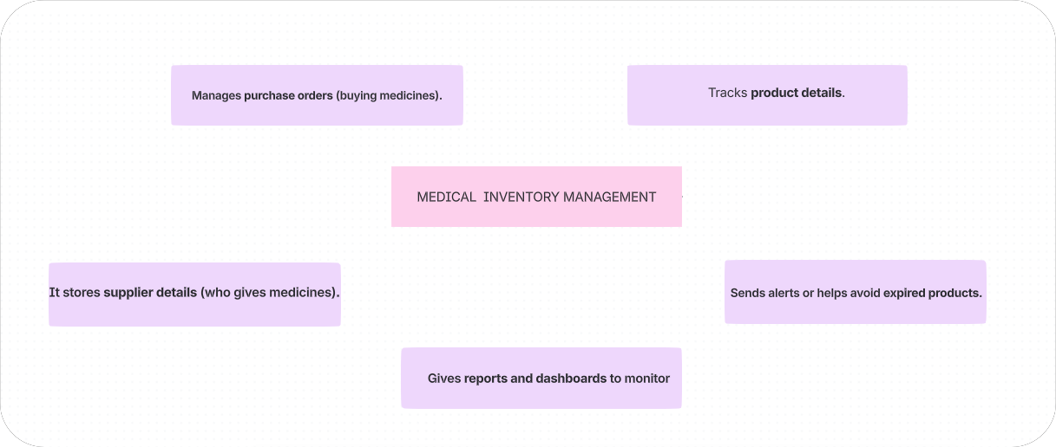

**PURPOSE:**

This project helps medical shops and hospitals easily manage medicine stock, purchase orders, and supplier details, track expiry dates automatically, and show useful reports all in one Salesforce system without manual calculation or errors.

# DEVELOPMENT PHASE

# **CREATING DEVELOPER ACCOUNT:**

# By using this url**:** <https://www.salesforce.com/form/developer-signup/?d=pb>

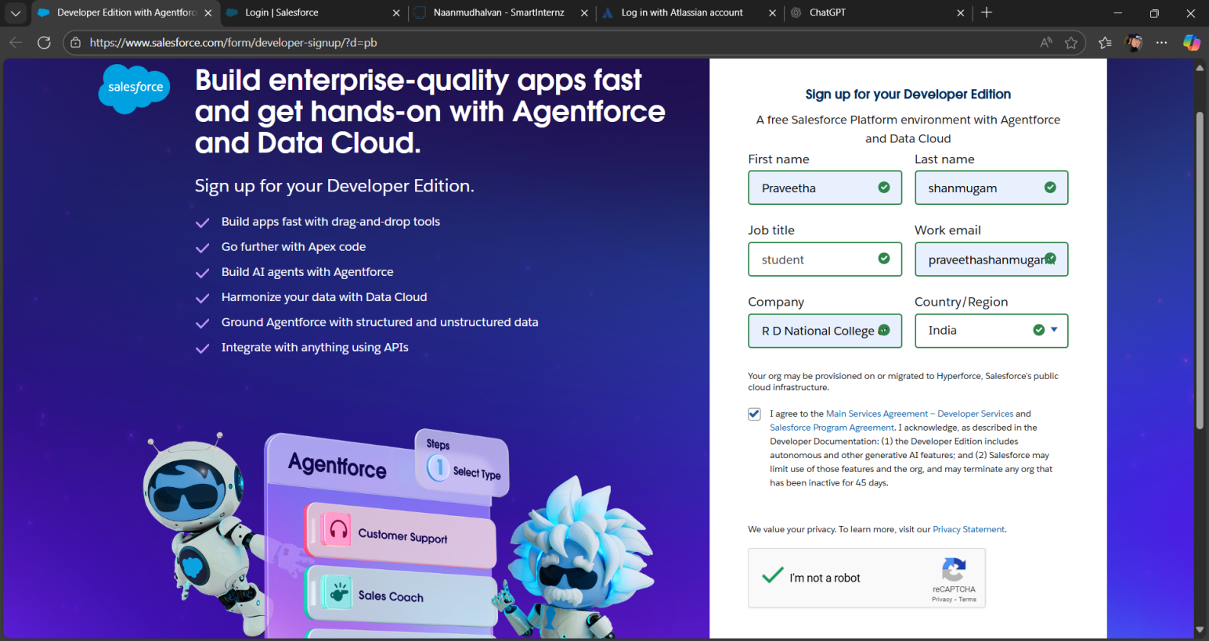

Created objects :Product,Purchase order,Order item,Inventory Transaction,Supplier

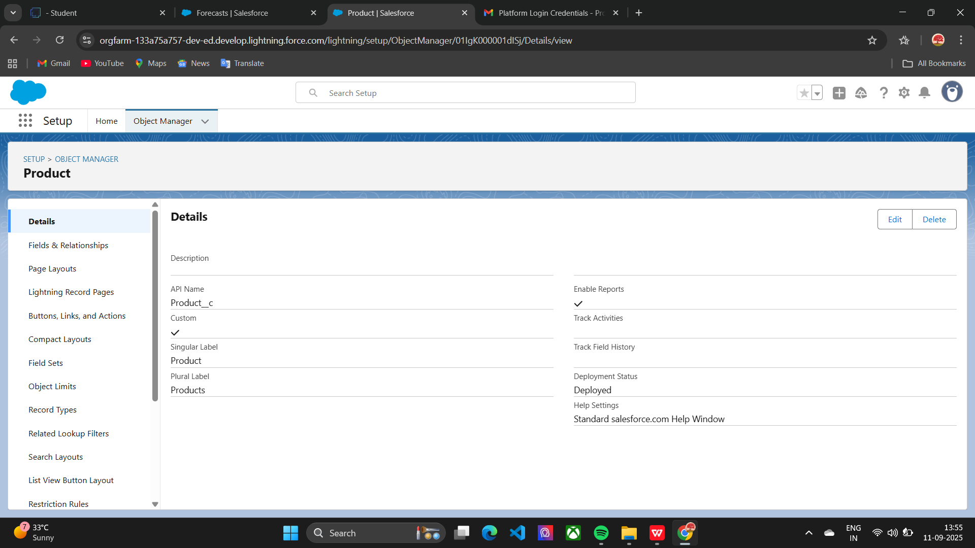

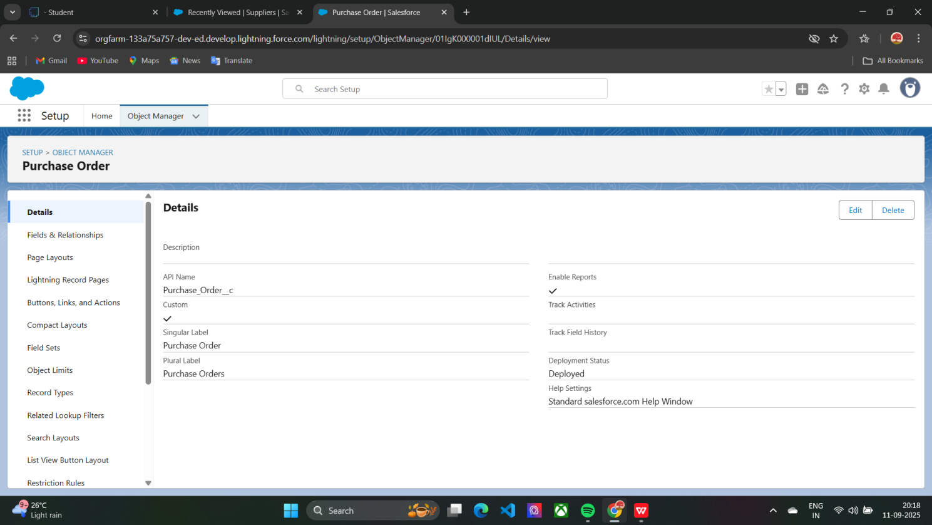

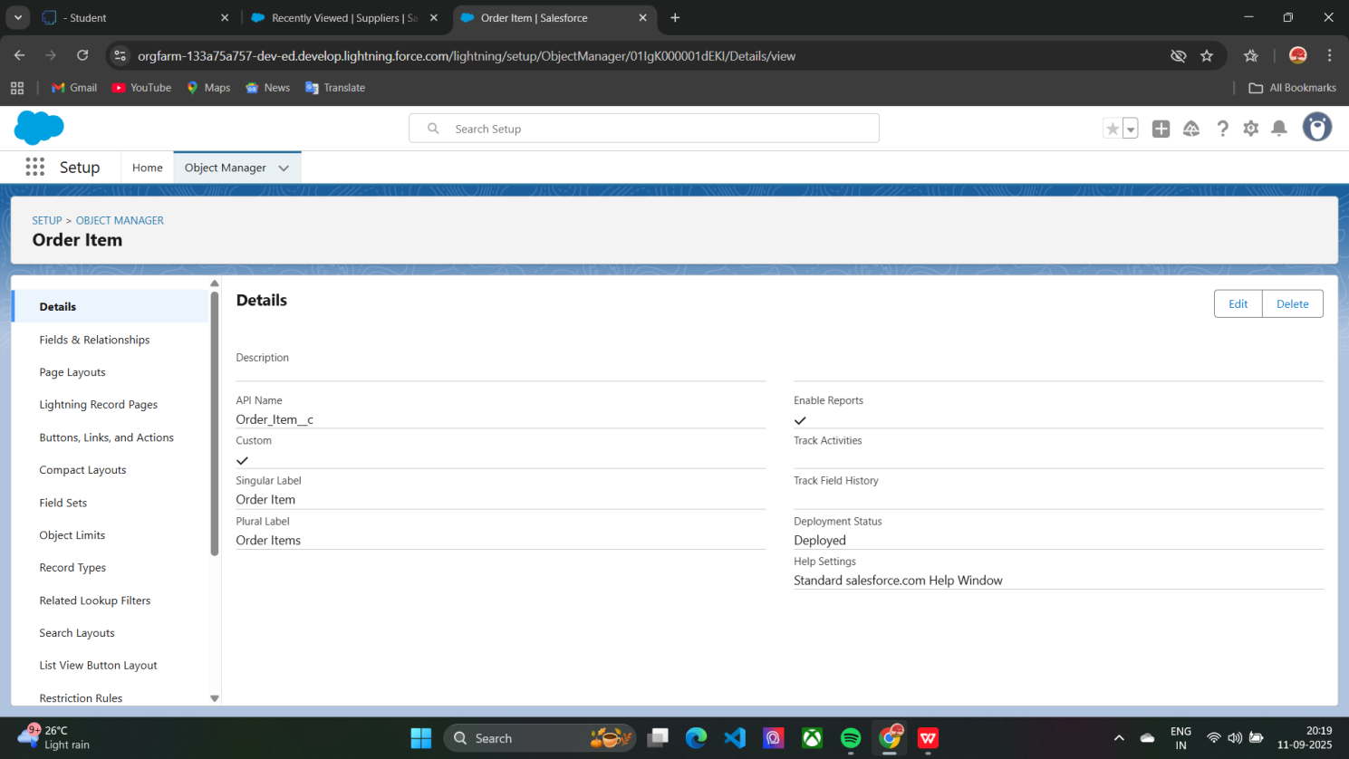

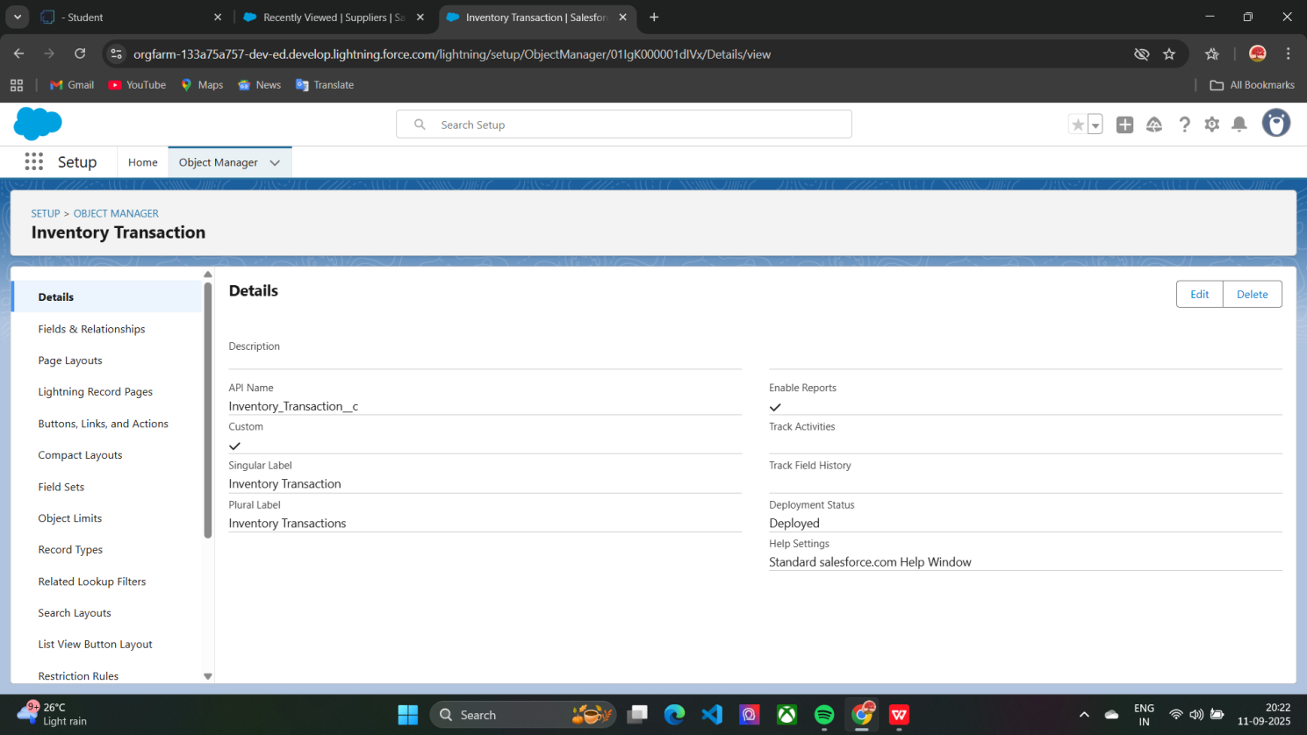

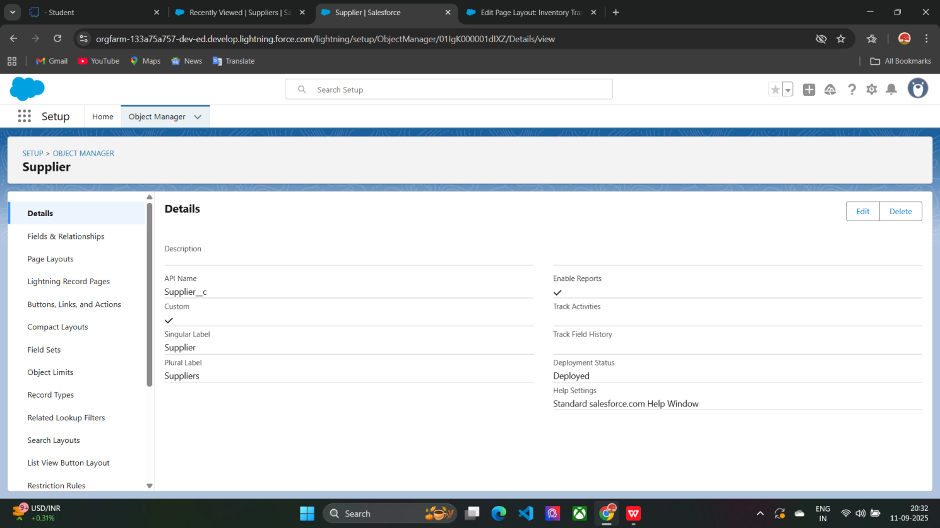

Configured fields and relationship :

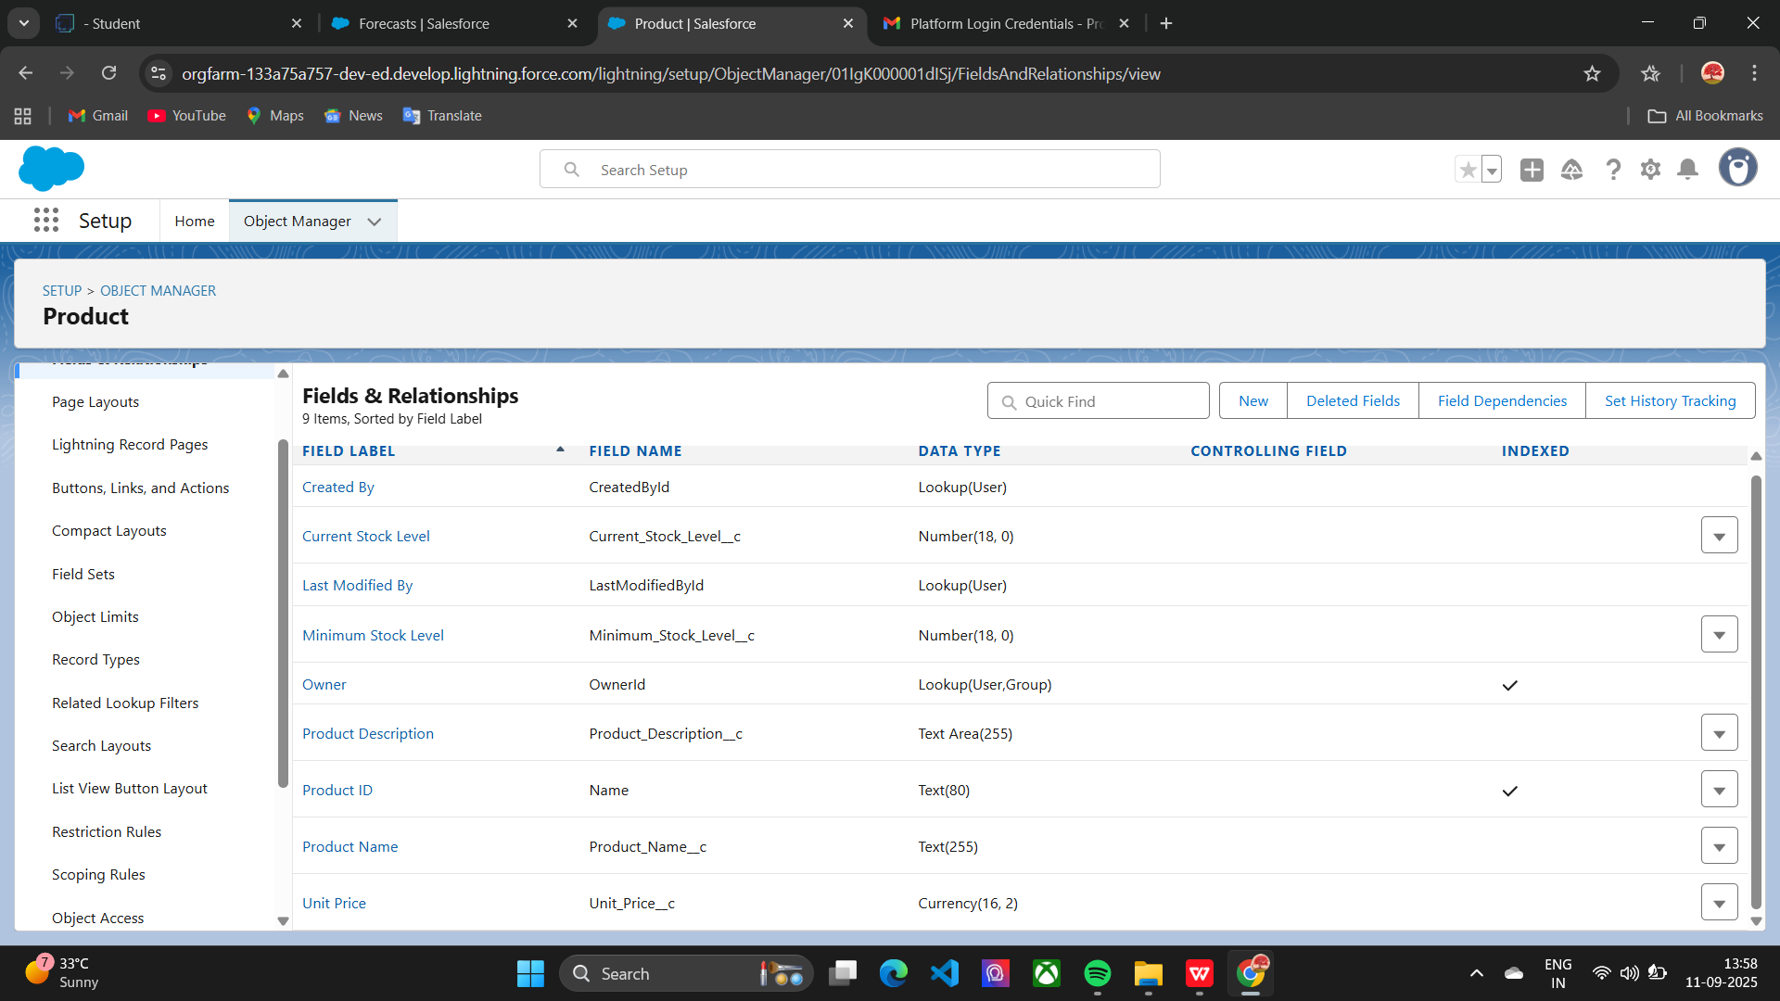

Developed Lightning App with relevant tabs :

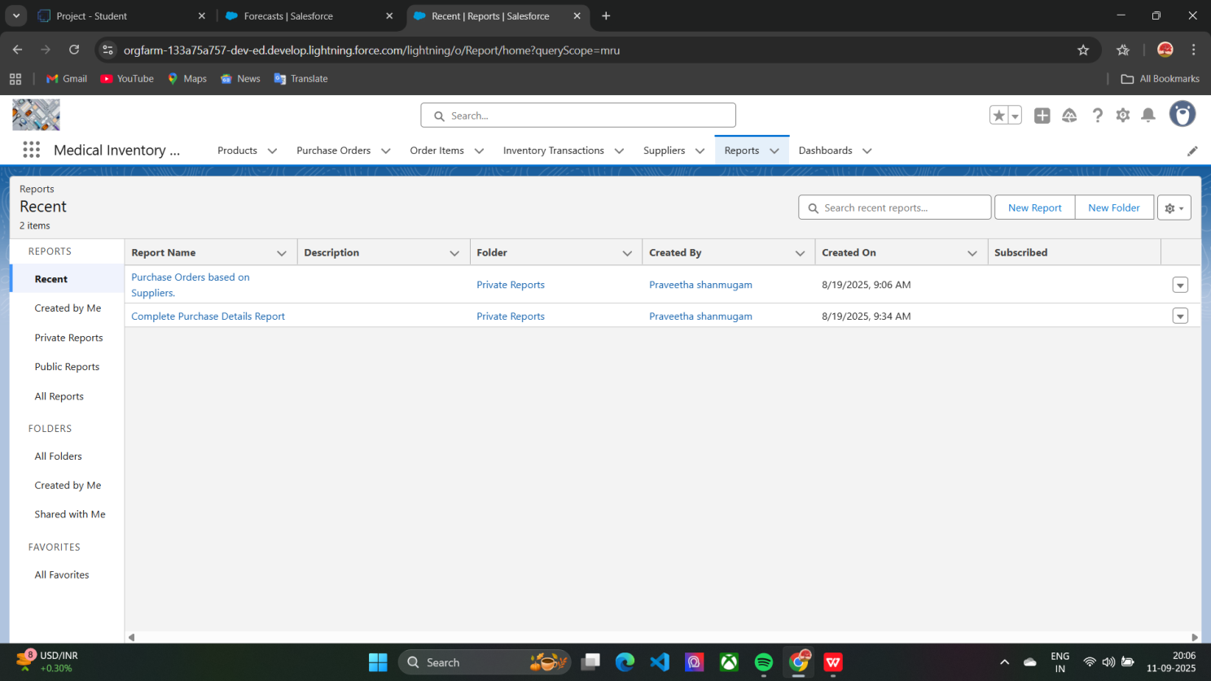

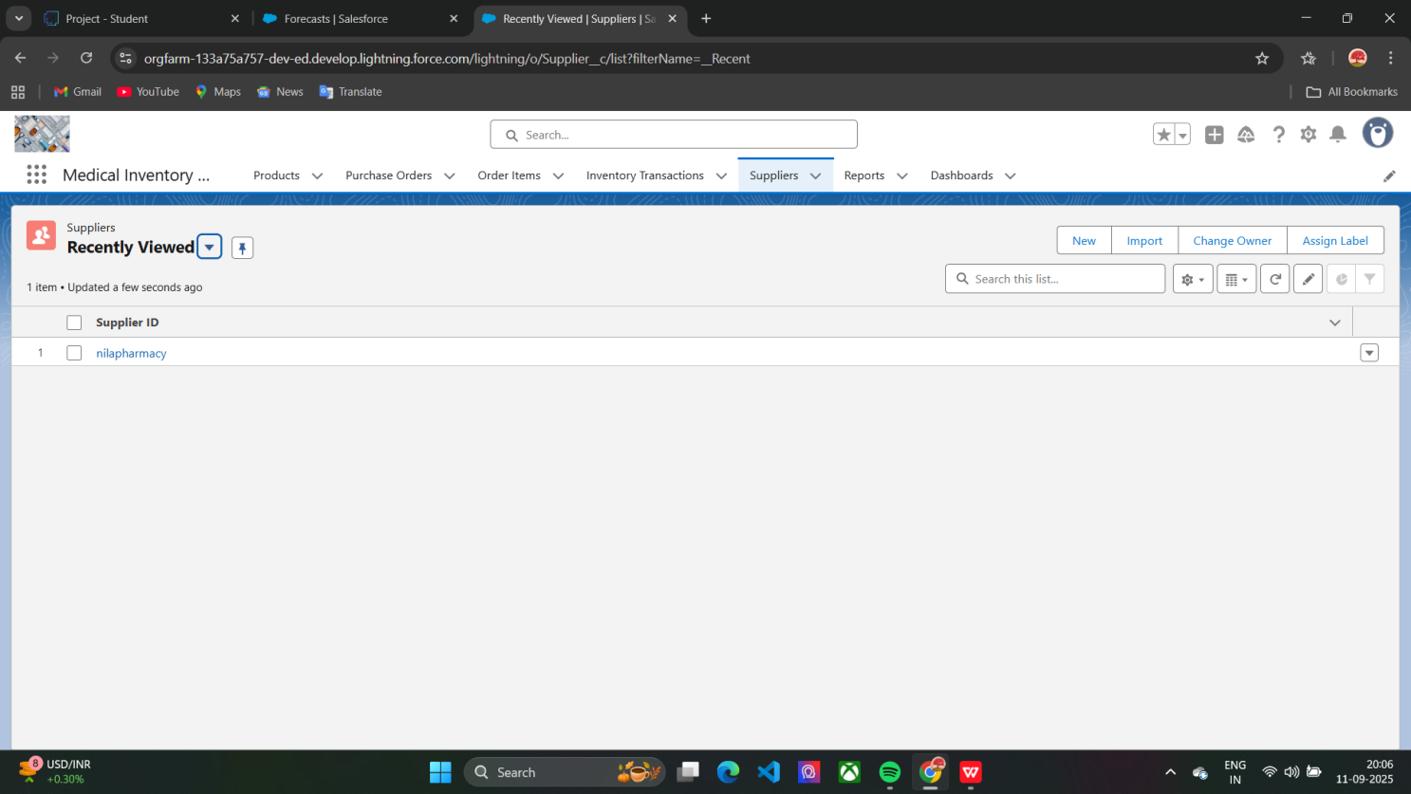

Implemented the flows for updating the actual delivery date:

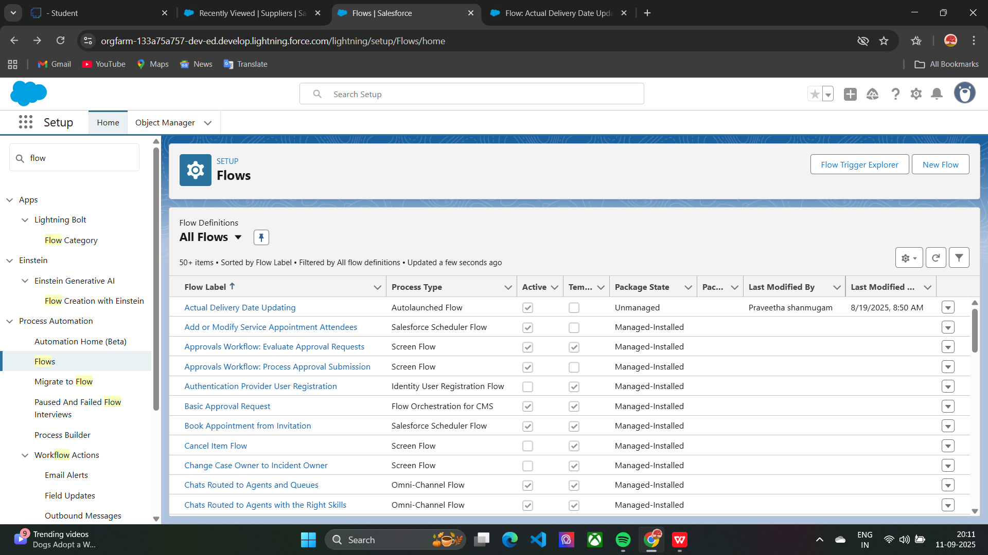

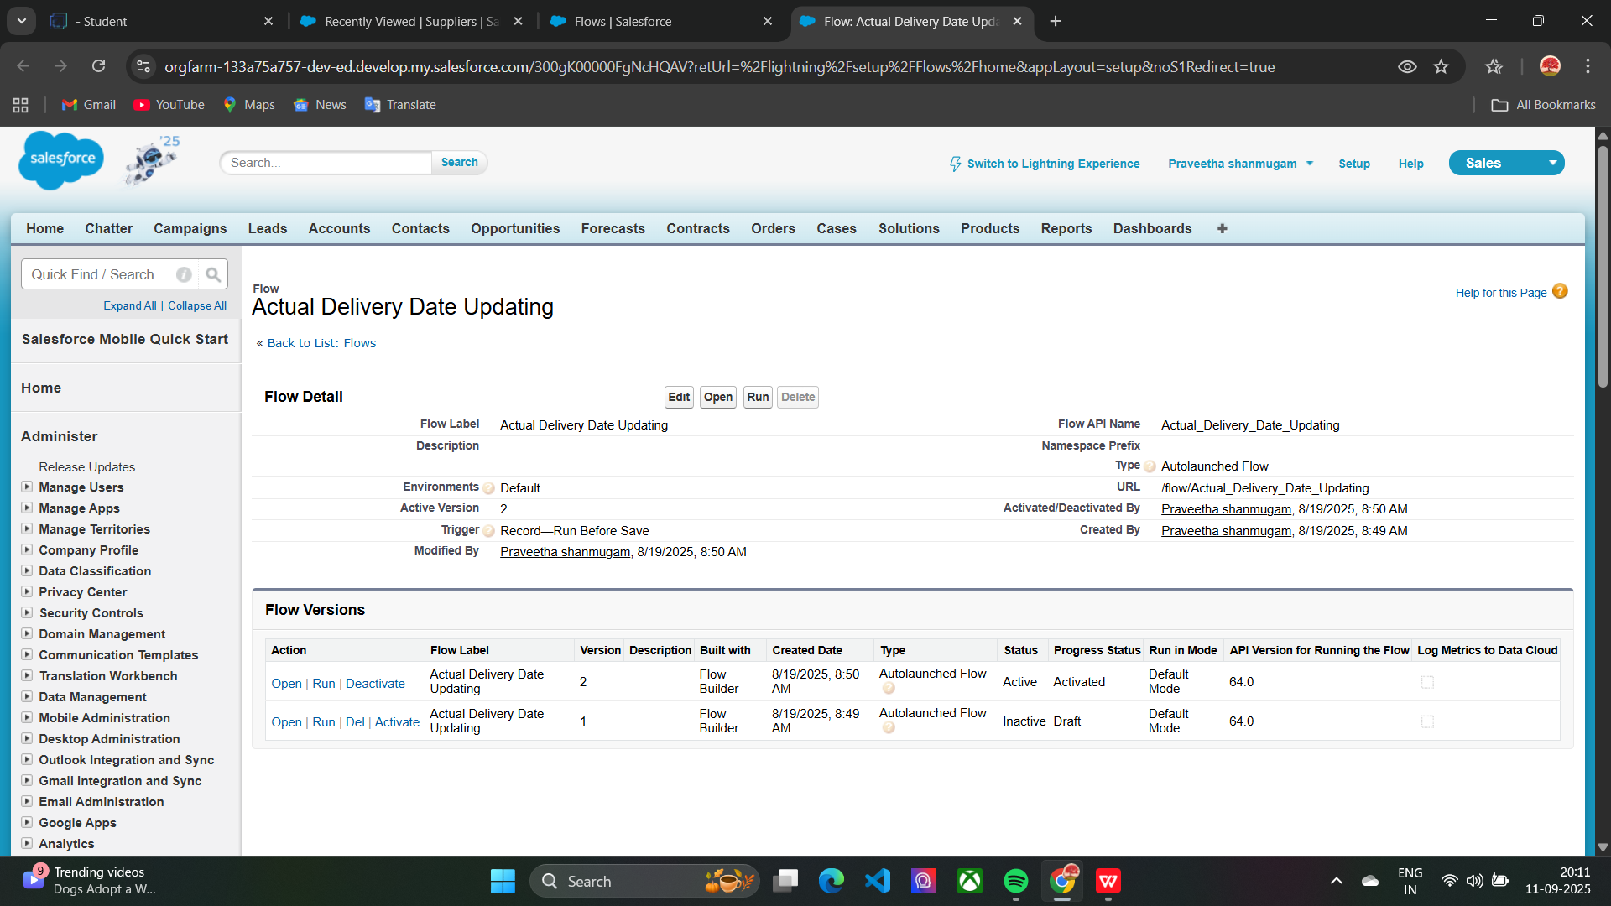

Editing the page layout in PRODUCT object:

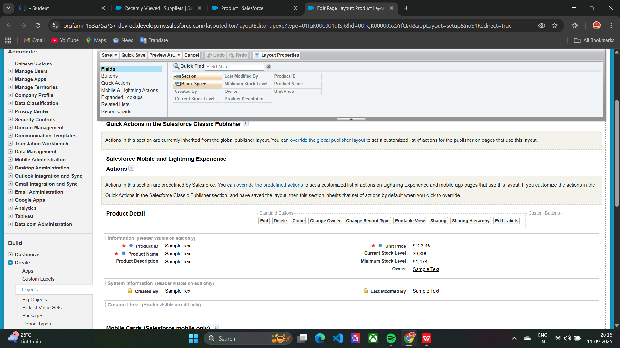

Editing the page layout in PURCHASE ORDER object:

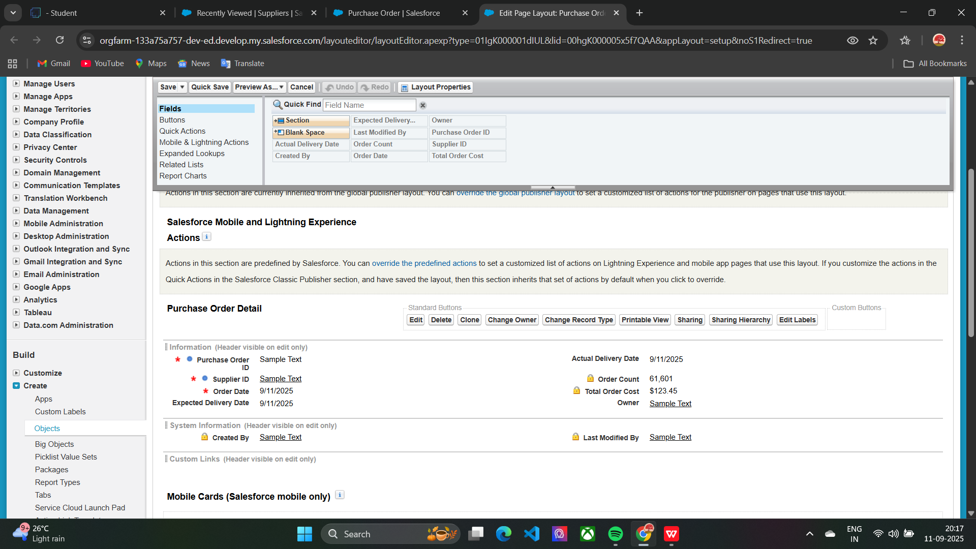

Editing the page layout in ORDER ITEM object:

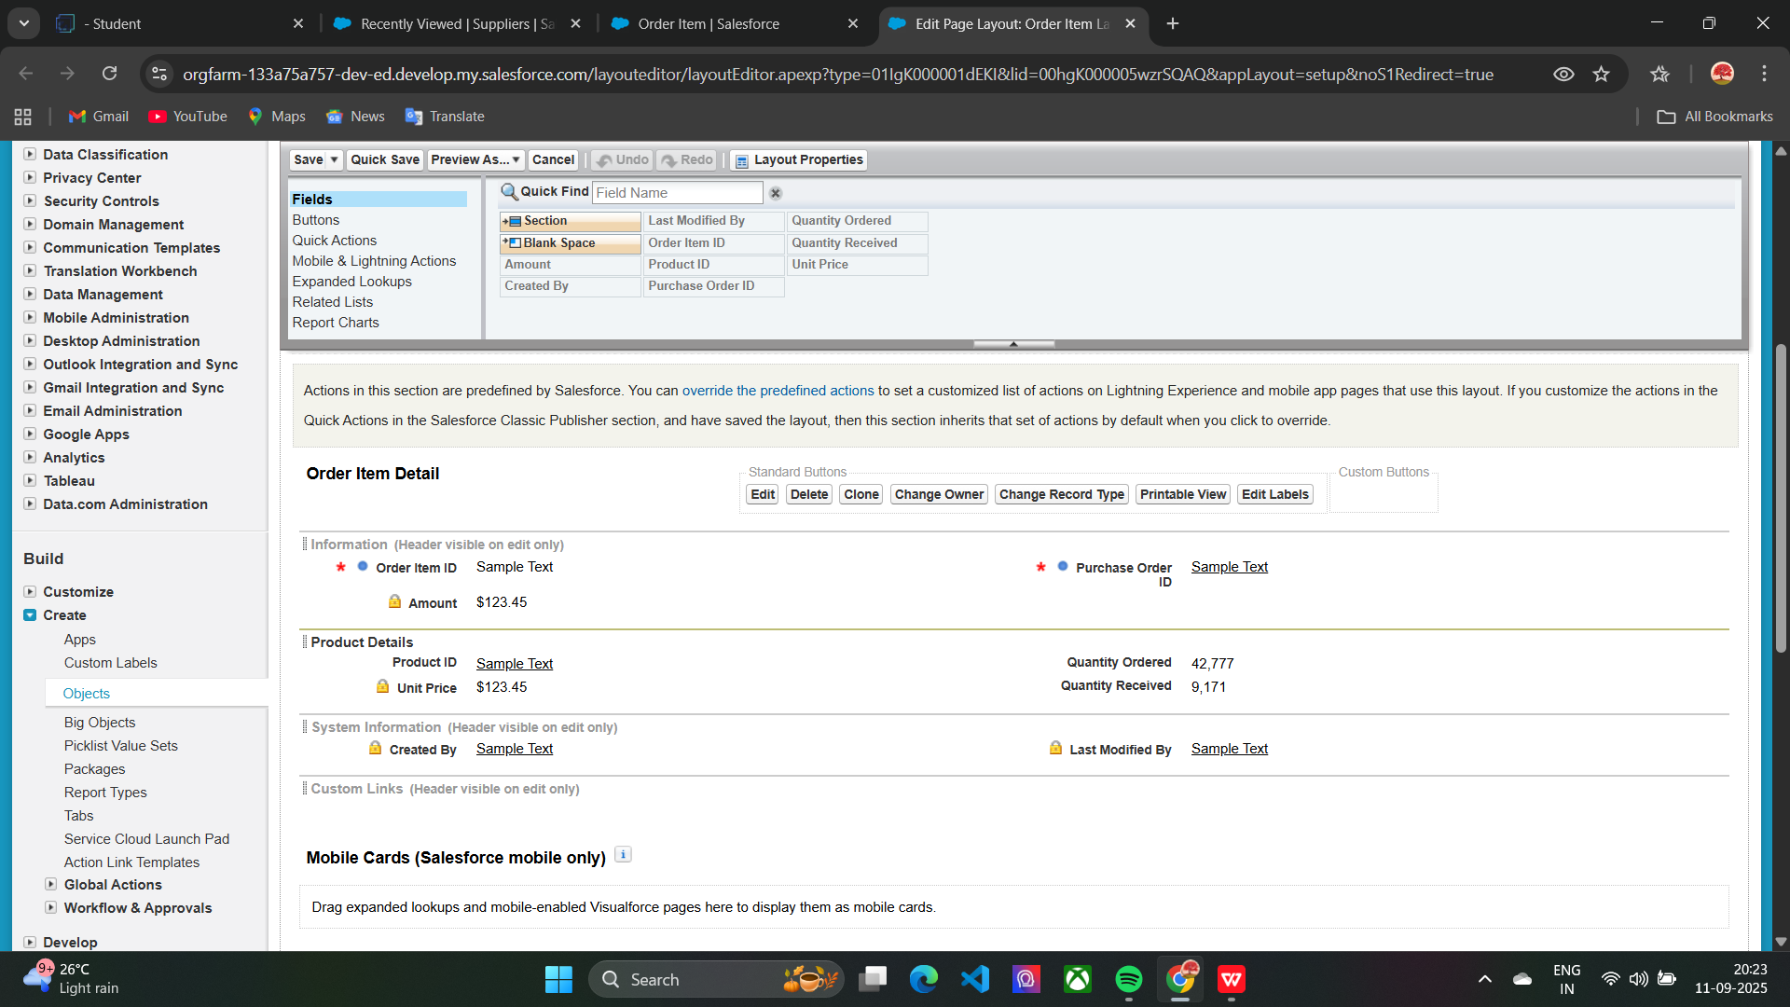

Editing the page layout in INVENTORY TRANSACTION object:

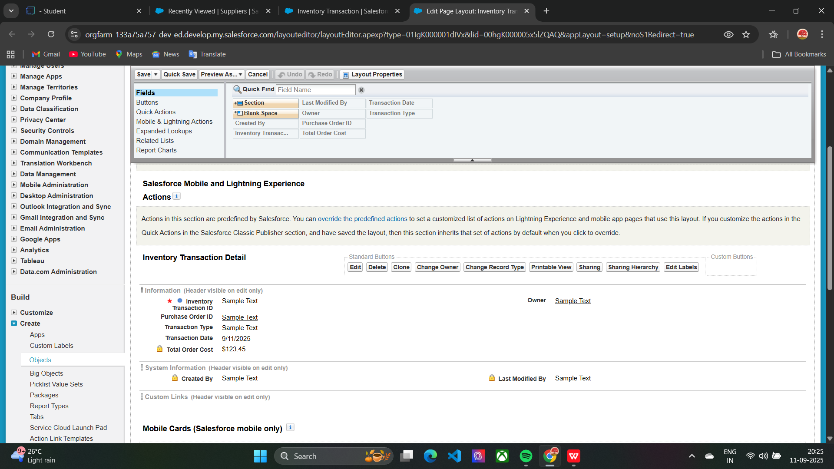

Editing the page layout in SUPPLIER object:

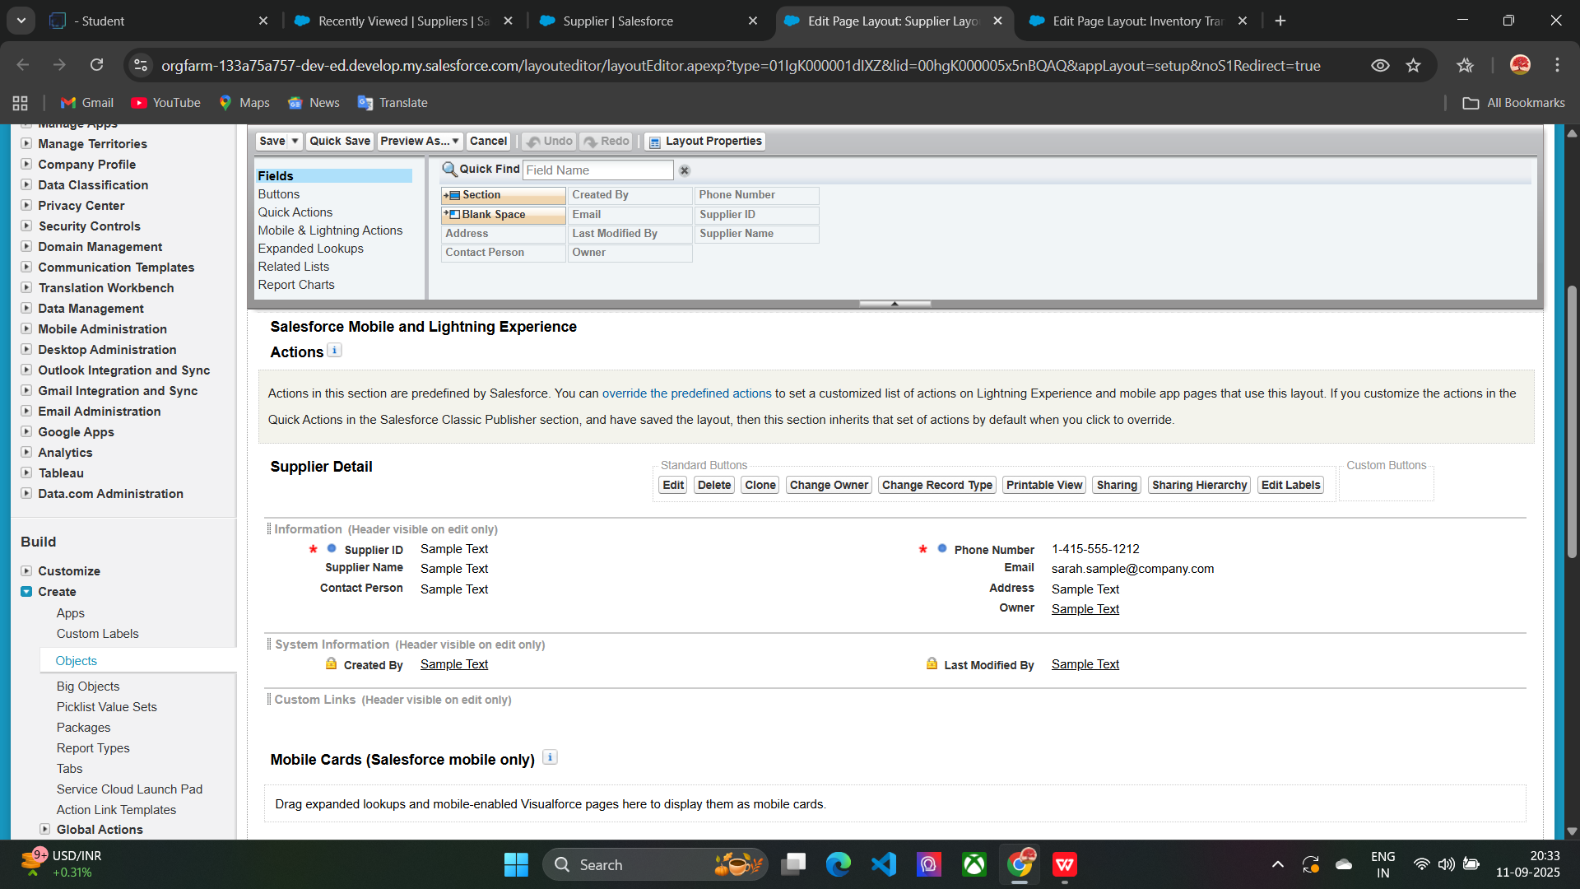

Creating compact layouts for objects:

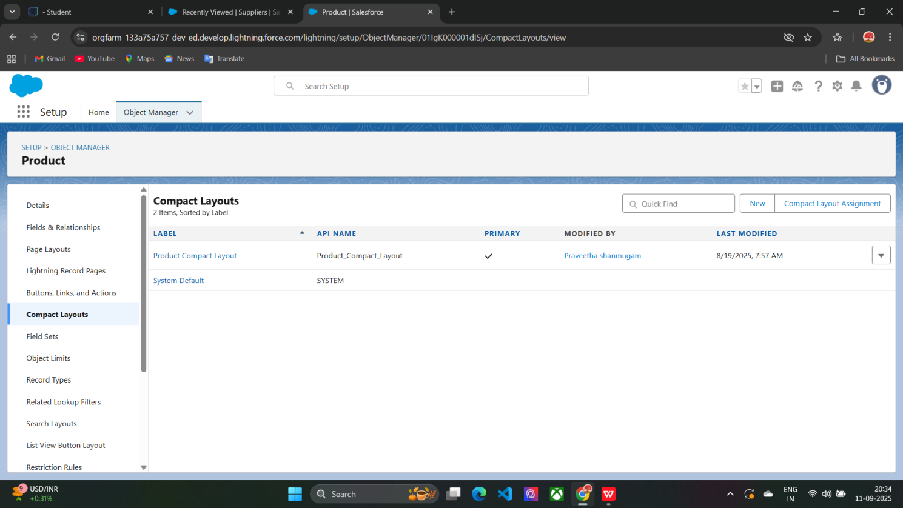

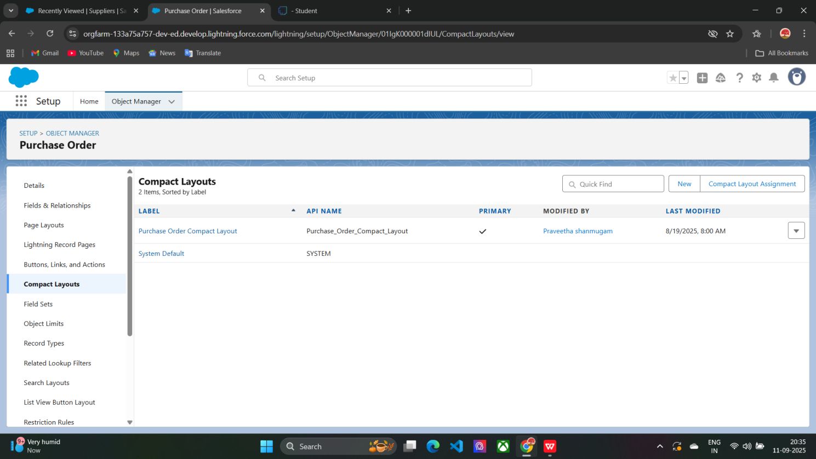

Validation rules for purchase order object:

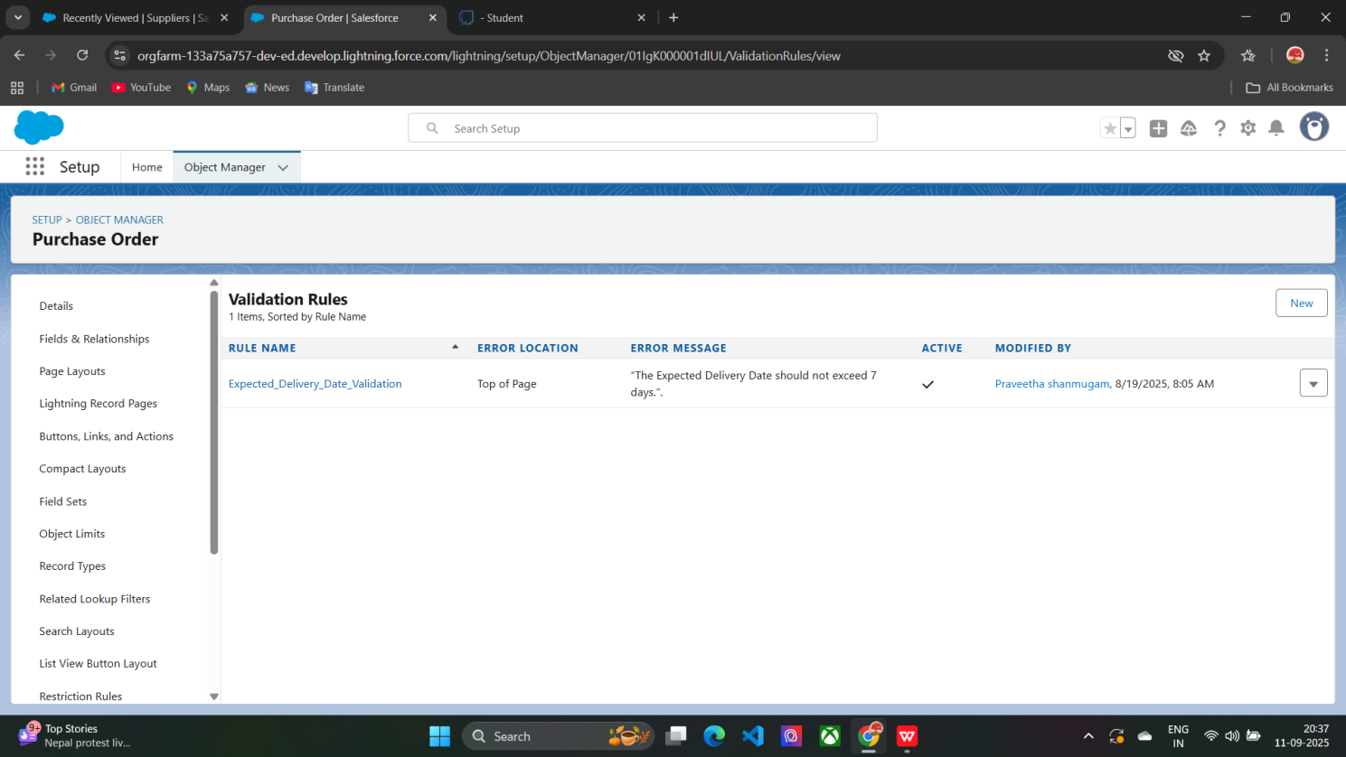

Creating profiles and roles:

**PROFILE**

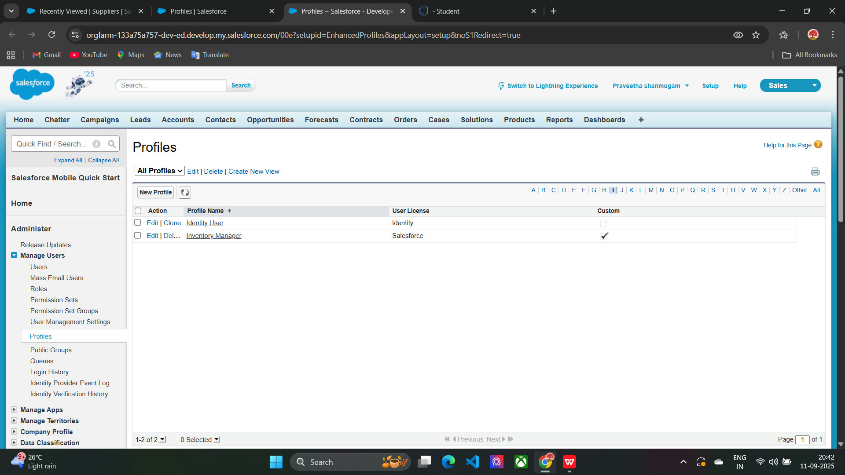

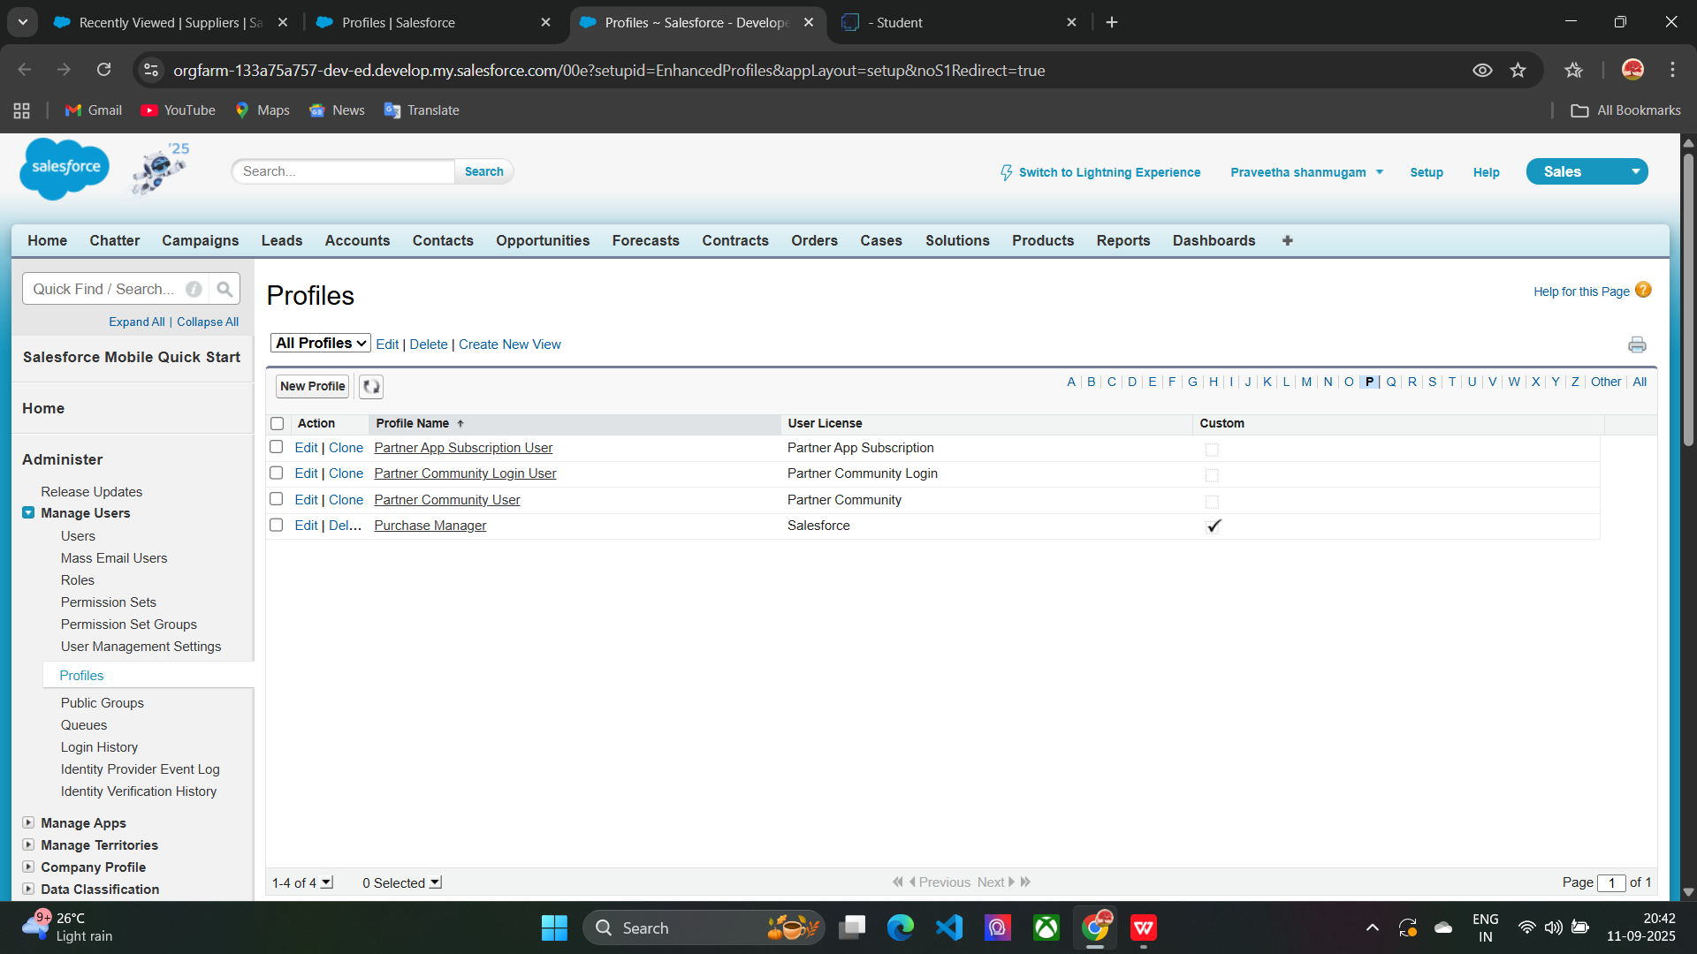

**ROLES**

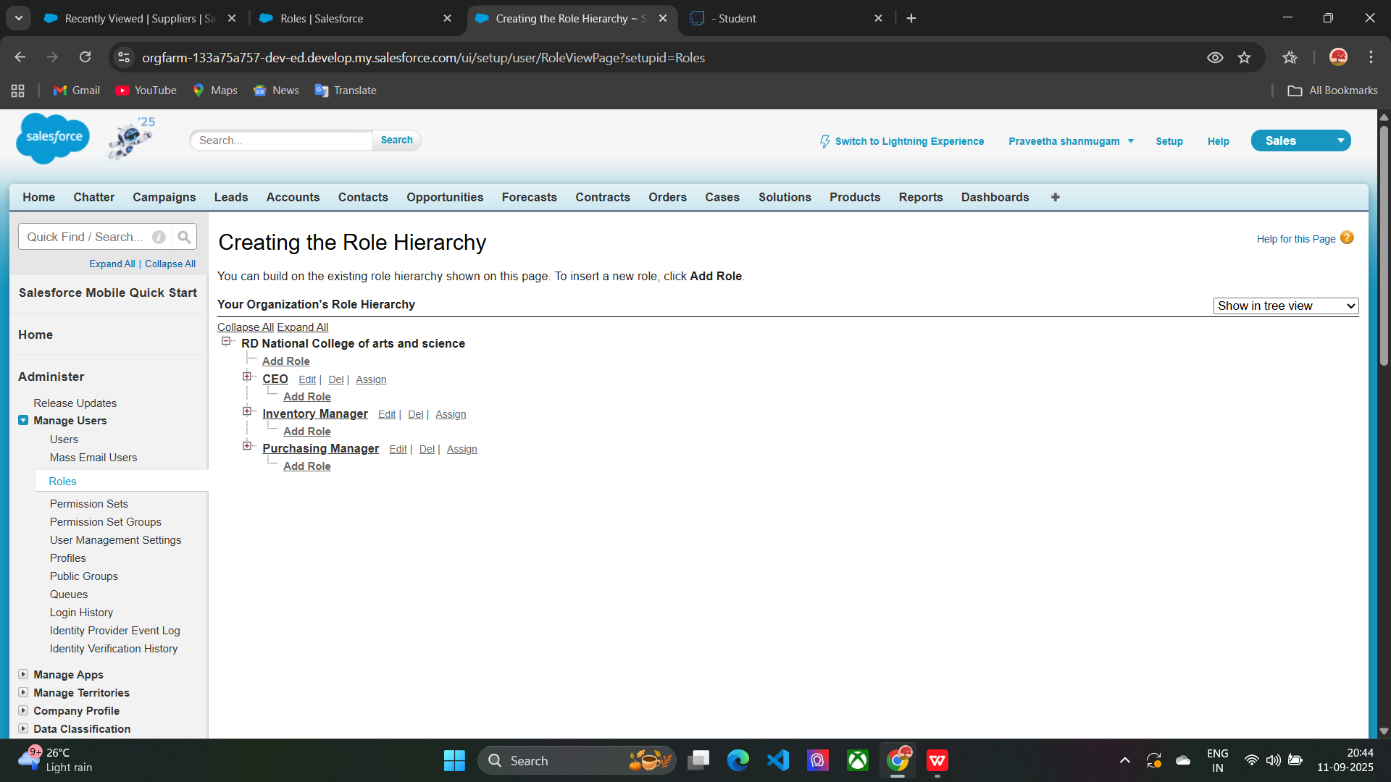

Creating permission sets for purchase order object:

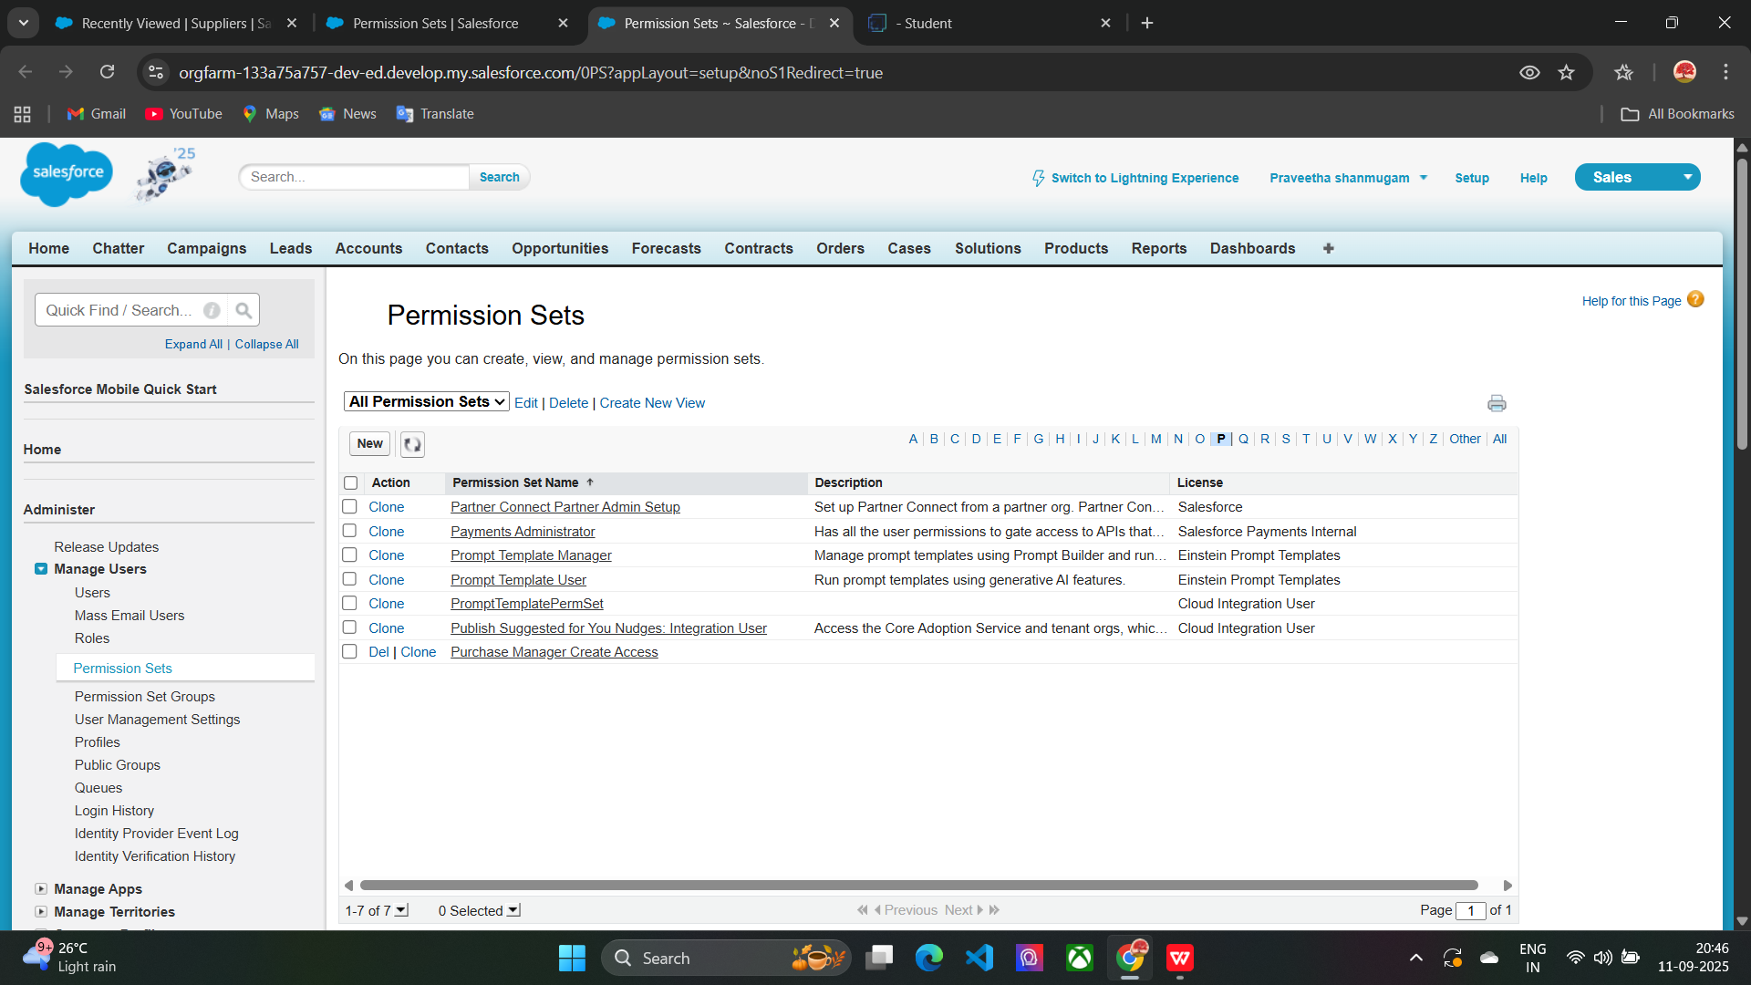

Creating a apex triggers:

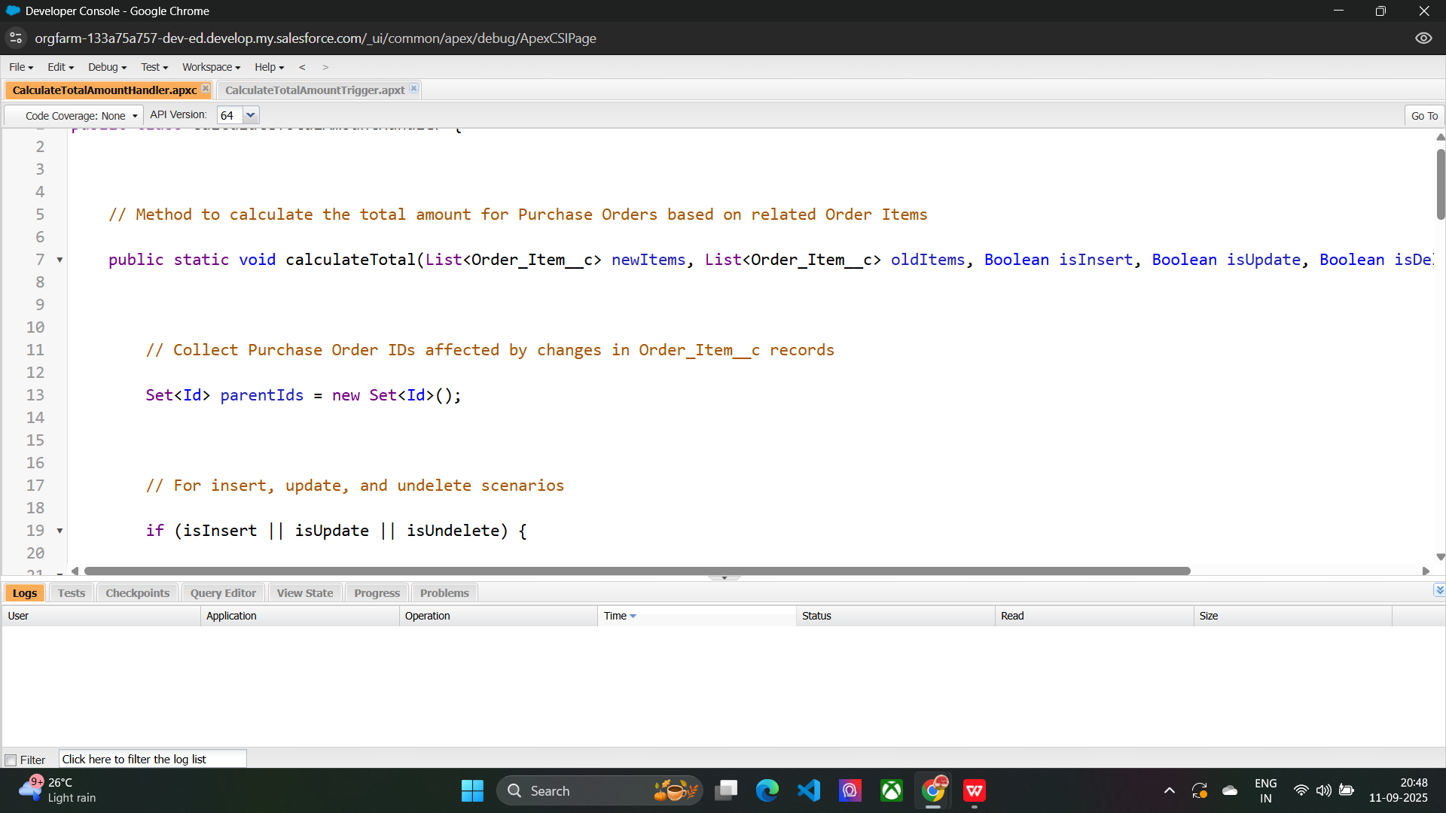

Creating a reports on complete supplier and purchase details:

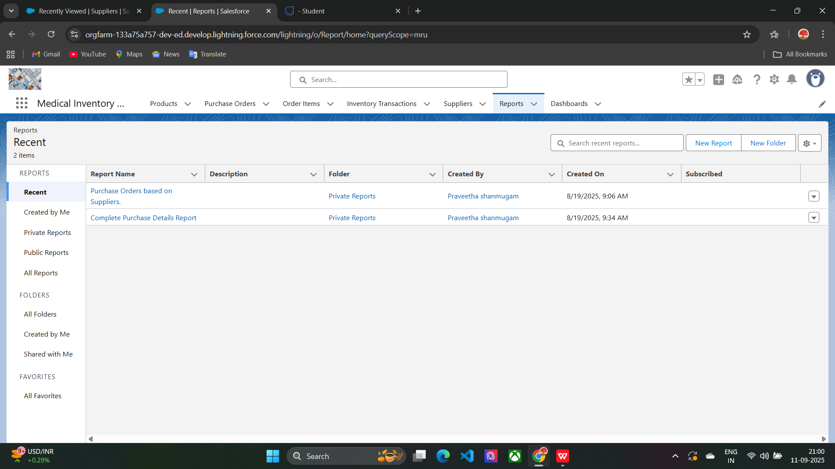

Creating dashboard for medical inventory management app:

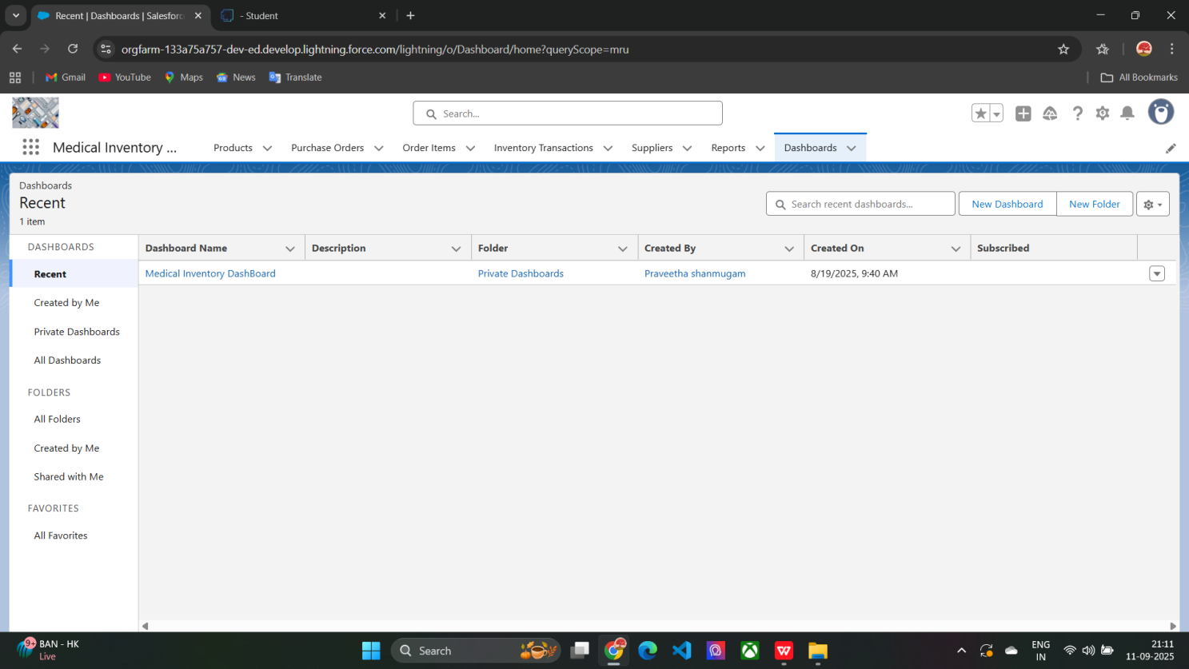

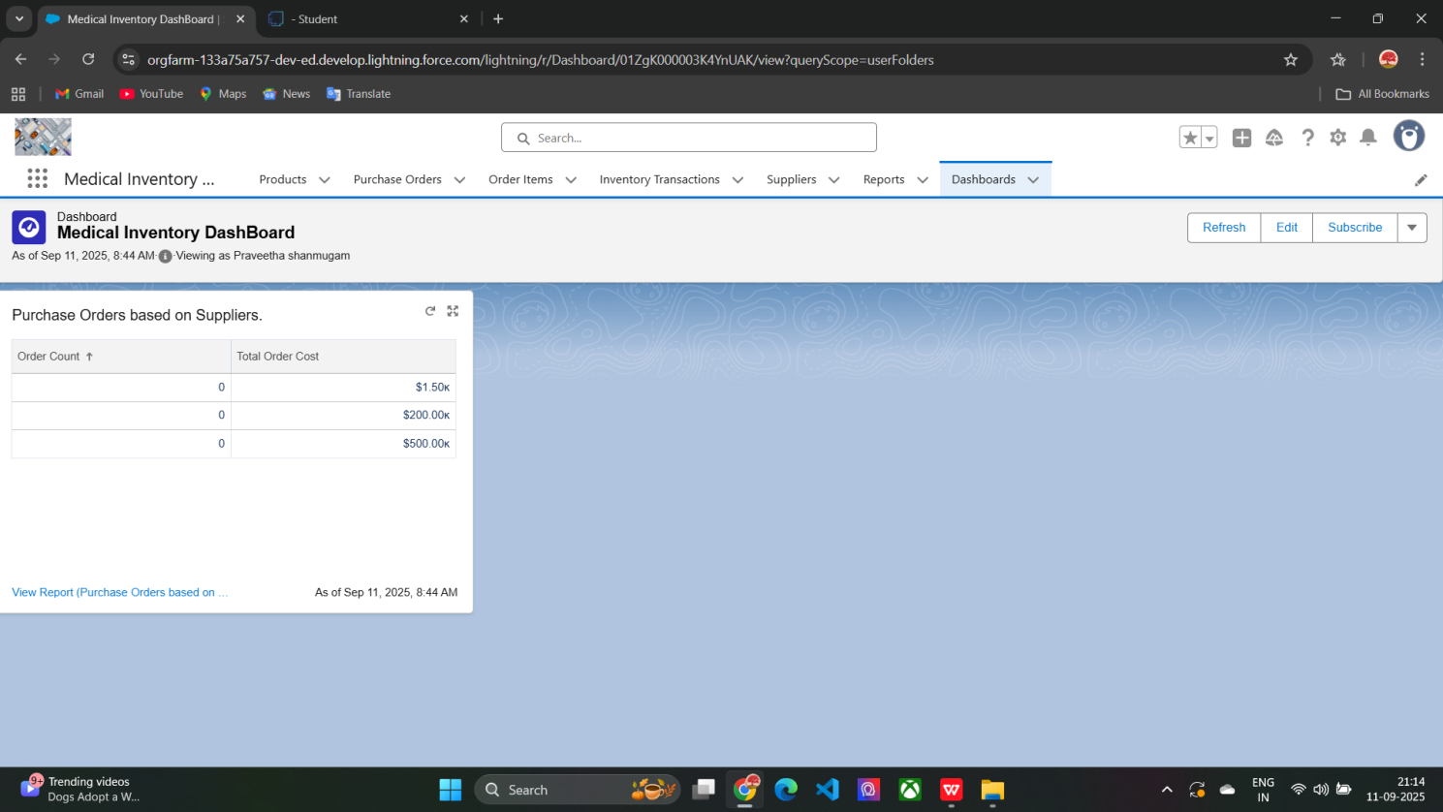

**FUNCTIONAL AND VALIDATION RULES CHECKING:**

Performance testing:

Validation rules checking:

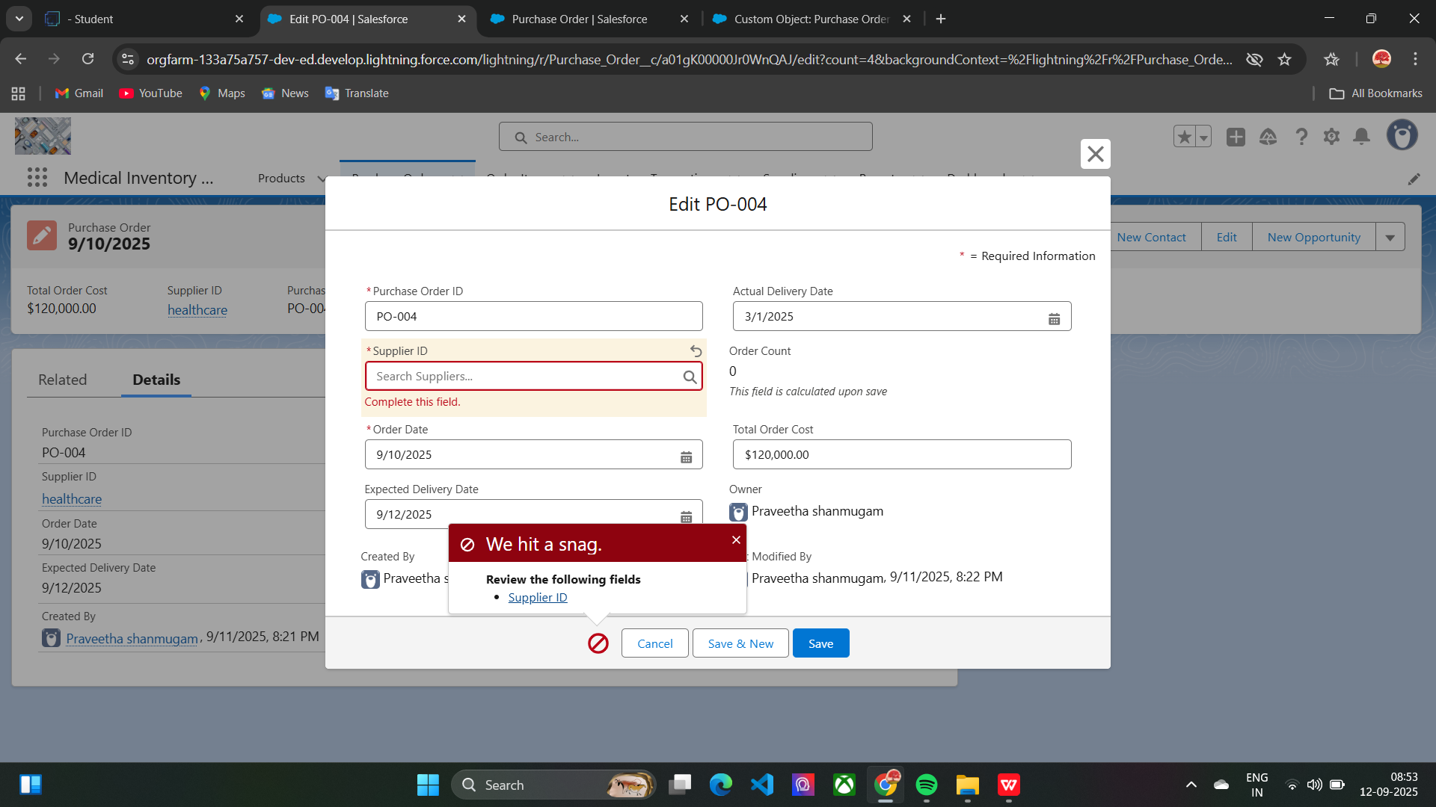

**RESULTS:**

**Output screenshots**

Tabs for Order item,Purchase order,Product,Inventory transactions,

suppliers

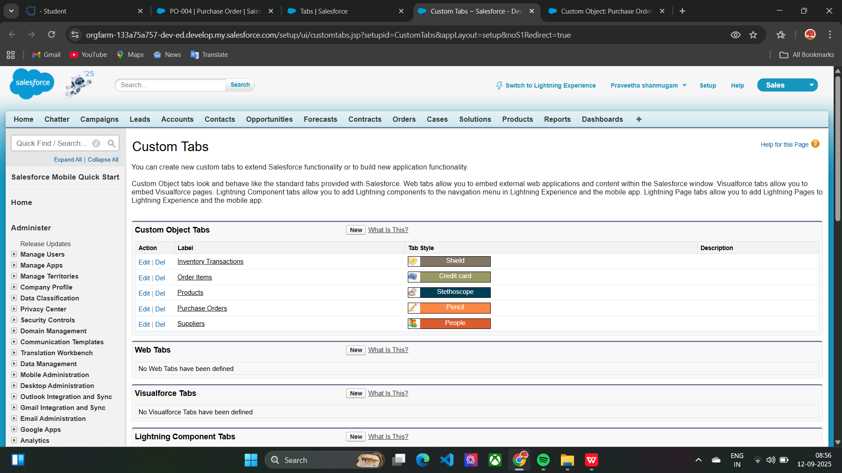

Reports :Purchase based on suppliers

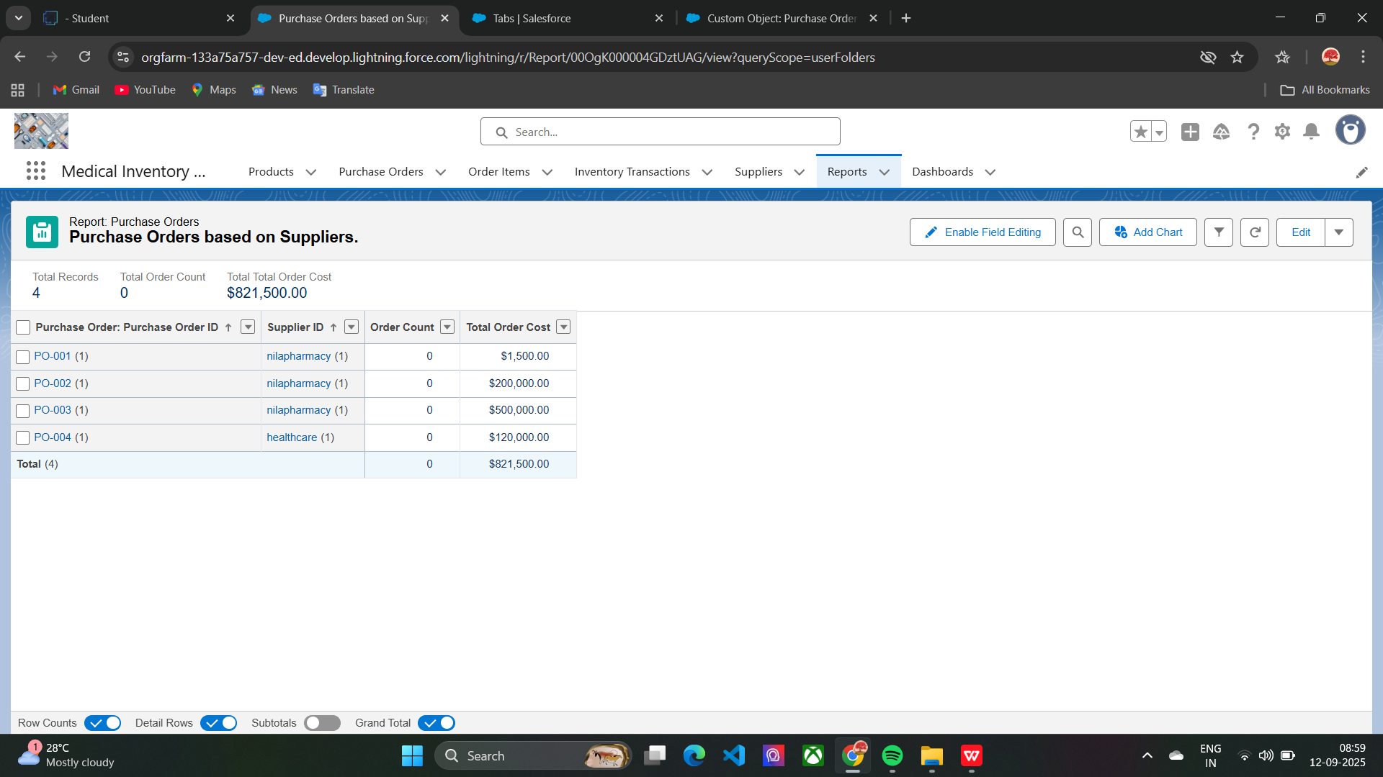

Flows runs:

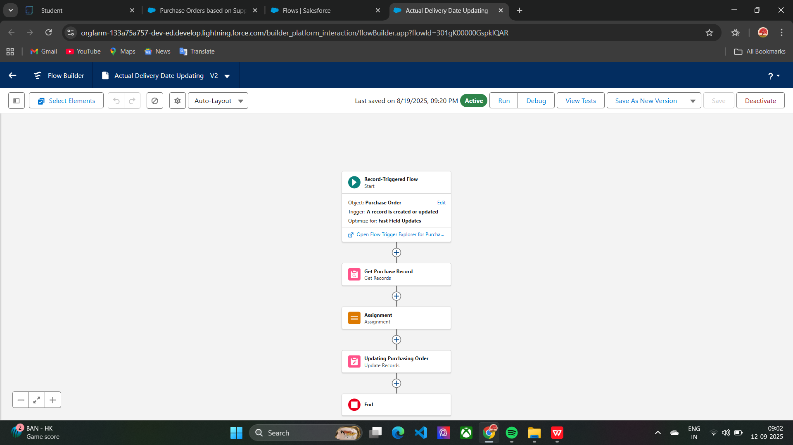

**CONCLUSION:**

This project helps medical stores and hospitals manage their stock, suppliers, and purchase orders easily.It tracks product expiry automatically to avoid using expired medicines.Using Salesforce automation, reports, and dashboards, inventory management becomes fast, accurate, and error-free.

**APPENDIX:**

Source code:Provided in Apex Triggers and Classes

trigger CalculateTotalAmountTrigger on Order_Item__c (after insert, after update, after delete, after undelete) {

    // Call the handler class to handle the logic

    CalculateTotalAmountHandler.calculateTotal(Trigger.new, Trigger.old, Trigger.isInsert, Trigger.isUpdate, Trigger.isDelete, Trigger.isUndelete);

}

public class CalculateTotalAmountHandler {

    // Method to calculate the total amount for Purchase Orders based on related Order Items

    public static void calculateTotal(List<Order_Item__c> newItems, List<Order_Item__c> oldItems, Boolean isInsert, Boolean isUpdate, Boolean isDelete, Boolean isUndelete) {

        // Collect Purchase Order IDs affected by changes in Order_Item__c records

        Set<Id> parentIds = new Set<Id>();

        // For insert, update, and undelete scenarios

        if (isInsert || isUpdate || isUndelete) {

            for (Order_Item__c ordItem : newItems) {

                parentIds.add(ordItem.Purchase_Order_Id__c);

            }

        }

        // For update and delete scenarios

        if (isUpdate || isDelete) {

            for (Order_Item__c ordItem : oldItems) {

                parentIds.add(ordItem.Purchase_Order_Id__c);

            }

        }

        // Calculate the total amounts for affected Purchase Orders

        Map<Id, Decimal> purchaseToUpdateMap = new Map<Id, Decimal>();

        if (!parentIds.isEmpty()) {

            // Perform an aggregate query to sum the Amount__c for each Purchase Order

            List<AggregateResult> aggrList = [

                SELECT Purchase_Order_Id__c, SUM(Amount__c) totalAmount

                FROM Order_Item__c

                WHERE Purchase_Order_Id__c IN :parentIds

                GROUP BY Purchase_Order_Id__c

            ];

            // Map the result to Purchase Order IDs

            for (AggregateResult aggr : aggrList) {

                Id purchaseOrderId = (Id)aggr.get('Purchase_Order_Id__c');

                Decimal totalAmount = (Decimal)aggr.get('totalAmount');

                purchaseToUpdateMap.put(purchaseOrderId, totalAmount);

            }

            // Prepare Purchase Order records for update

            List<Purchase_Order__c> purchaseToUpdate = new List<Purchase_Order__c>();

            for (Id purchaseOrderId : purchaseToUpdateMap.keySet()) {

                Purchase_Order__c purchaseOrder = new Purchase_Order__c(Id = purchaseOrderId, Total_Order_cost__c = purchaseToUpdateMap.get(purchaseOrderId));

                purchaseToUpdate.add(purchaseOrder);

            }

            // Update Purchase Orders if there are any changes

            if (!purchaseToUpdate.isEmpty()) {

                update purchaseToUpdate;

            }

        }

    }

}